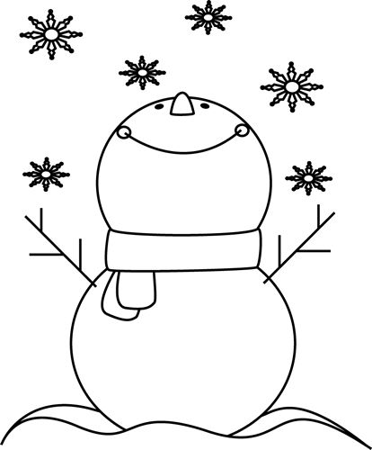 | 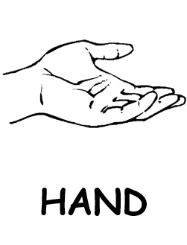 | 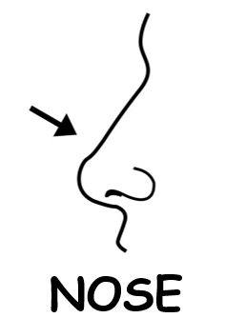 | 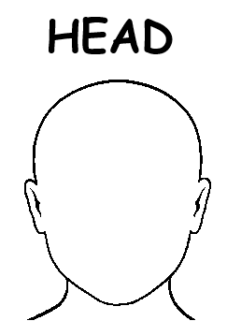
♫ Snowflake, snowflake,  little snowflake.  Little snowflake  falling from the sky.  Snowflake, snowflake, little snowflake.  Falling, … 9krát  falling on my head.  falling on my nose.  falling in my hand.  https://www.youtube.com/watch?v=tbbKjDjMDok | NAME:  ________  SNOWFLAKE  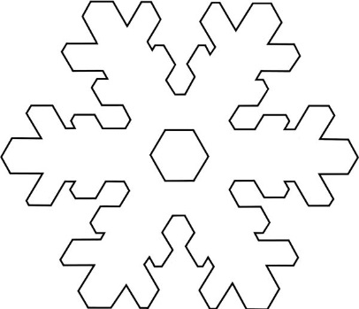 | 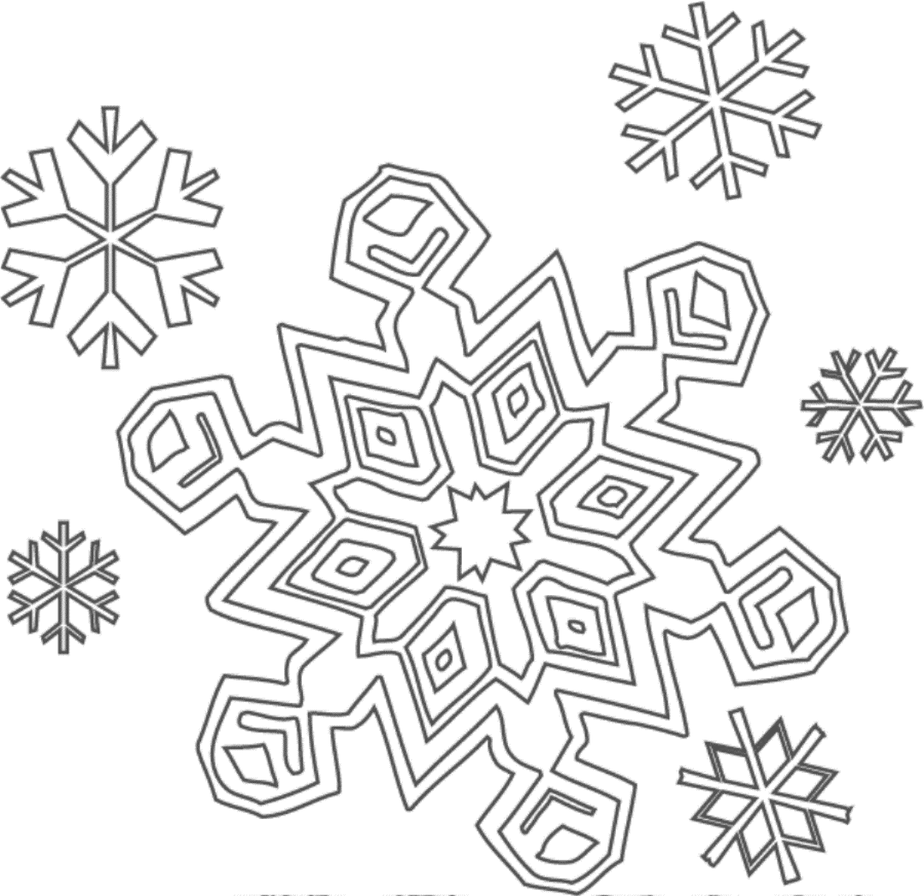  LITTLE  SNOWFLAKE | 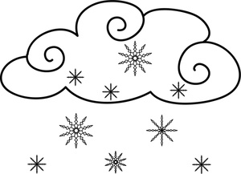  FALLING  FROM THE SKY

